

Ivette Estrada Jeremy Humpherys Jonathan Nazzaro Katie Kramer Steven Somenek

Project Specifications Spring 2015

Table of Contents

Executive Summary 2

The Clients 3

Client Introductions 3

The Problem 5

The Solution 5

The Contributors 5

Contributor Introductions 6

Functionality 13

Planned 13

Actual 13

Technology Used 13

Hosting Service 13

Version 0.1 14

Version 0.2 14

Version 0.3 14

Version 0.4 14

Version 0.5 15

Version 0.6 15

Preview 1.0 Release 15

Code Documentation 16

Important GoDaddy Information 35

Testing and Evaluation 36

Testing 36

Automation 36

Moving Forward 37

Executive Summary

TalkShop is a web application that facilitates connections between guest speakers and teachers. Often times, teachers have a difficult time finding a guest speaker within a particular field who is nearby or in the area. This website will allow teachers to search through various speaker profiles in order to find the perfect candidate for their intended purpose. Potential speakers will have the ability to create a profile and put their best foot forward so that they may acquire multiple speaking opportunities. TalkShop will essentially be a social media site for bringing together teachers and professional guest speakers. This website will prove to be a very valuable tool in the learning environment.

TalkShop was conceived at Startup Weekend in Phoenix, Arizona on November 14th, 2014. The original masterminds of the idea include Dr. Joseph Clark of Arizona State University, Michelle Love of Grand Canyon University, and Michelle’s close friend and colleague, Karyn Zogopoulos. Dr. Clark presented the idea to his systems design course and recruited a team of information systems students to implement the website.

Over the course of approximately four months, the students worked diligently to create a website that would serve its intended purpose and please the sponsors. With each passing milestone came many trials and tribulations; however, the students are pleased to announce that the final product is now fully-functional and live on <http://www.talk-shop.net>.

Although the project was successful, the students were unable to fulfill all of the proposed tasks for TalkShop. Due to the fact that the website was developed entirely from scratch in just a little over 16 weeks, the focus was to create at least a minimum viable product that would be live and functional. As of now, TalkShop is comprised of:

* Home Page
* Speaker and Teacher Profiles
* Ability to Contact Teachers/Speakers
* Search Functionality
* Register and Login Capabilities

The students have prepared this document as a tool for future developers assigned to this project so that they are able to understand the entire implementation process thus far.

The Clients

The clients, Dr. Joe Clark, Michelle Love, and Karyn Zogopoulos met at Start-Up Weekend in Phoenix, Arizona on November 14th, 2014. It was here that they came up with the idea for TalkShop. Due to a lack of time and necessary skills, the clients were unable to establish the website on their own. With permission from the team at Start-Up Weekend, Dr. Clark presented the idea to his IS students with hopes that someone would volunteer to help. It wasn’t until late April 2015 that the idea became a reality.

Client Introductions

**Dr. Joseph Clark – Arizona State University -** [**joeclark.phd@gmail.com**](mailto:joeclark.phd@gmail.com)

Dr. Clark is a web developer in the 56kbps modem era. He earned his doctorate in Information Systems from the University of Southern California in 2012, followed by a post-doctorate at the University of Nebraska at Omaha. Dr. Clark is currently teaching CIS 440, the undergrad information systems capstone course at Arizona State University.

Dr. Clark’s interests include:

* Doing Data Science in Teams
* DevOps for Big Data
* Agility and Entrepreneurship
* Data Visualization
* NoSQL Databases

**Michelle Love – Grand Canyon University -** [**http://shellylovecreative.com/**](http://shellylovecreative.com/)

Michelle Love teaches graduate and undergraduate level marketing classes at Grand Canyon University. She enjoys having guest speakers from the industry to share their experiences with her students. Michelle is also a very talented photographer. A client of hers describes her as, “focused, creative and open to ideas. She communicates her vision in a professional manner and has a portfolio full of variety and talent. She is highly motivated and works well with many different types of people and personalities. Michelle's time management makes her on point and lends to her ability to focus on a plan. She is professional, creative, and very talented!

Michelle’s top skills include:

* Public Speaking
* University Teaching
* Higher Education
* Faculty Training
* Photography
* Start-Up Ventures
* Entrepreneurship

**Karyn Zogopoulos – Professional Speaker –** [**karynaudra@gmail.com**](mailto:karynaudra@gmail.com)

Karyn is a close friend and colleague of Michelle Love. Karyn and Michelle attended start-up weekend together and came up with the idea for TalkShop. Karyn is a professional speaker and has been presenting for EDMC (Educational Management Corporation) for many years. Considering that TalkShop has a direct impact on her field of expertise, Karyn is very invested in the progress and success of the website.

Michelle’s top skills include:

* Professional Speaking
* Professional Training and Coaching

The Problem

TalkShop aims to resolve the disconnect between professional speakers and teachers. Most teachers believe that professional speakers are a great resource in the classroom. Speakers are able to educate students on a “real-life” level by sharing information about their own projects or experiences in a particular field. Guest speakers aim to educate and motivate; however, professional speakers are difficult to come by. One of the most common fears in the US is public speaking. Therefore, finding a passionate speaker who speaks about your desired topic and is in your area can be very challenging. Currently, there is no formal method for teachers to contact speakers and vice versa.

The Solution

The TalkShop website will provide a solution to this dilemma by enabling teachers and speakers to create profiles about themselves and what they are looking for. Teachers and speakers will be able to browse listings and contact one another if they are interested in a particular opportunity. TalkShop will bridge the communication gap between teachers and guest speakers.

Taking into consideration the clients’ vision and intentions for the website, the students were able to create a fully functioning website entirely from scratch. The team designed a modern and easy to navigate website that fulfills its intended purpose. Teachers and professional speakers are now able to create a profile, with or without a listing, as well as search through the profiles to find exactly what they’re looking for.

The Contributors

The developers behind talk-shop.net are all students of Dr. Clark’s undergraduate CIS capstone course. At the beginning of the semester, students were told to assemble into groups of five and choose an IS project to work on for the next 16 weeks. Ivette, Jon, Jeremy, Katie, and Steven were all friends prior to entering the course and were confident that each of their skill sets combined would facilitate a smooth implementation process. When Dr. Clark proposed the idea of TalkShop, the team was immediately on board. Each student is proud of the website they’ve worked so hard to complete, and are excited for the future of TalkShop!

Contributor Introductions

Each developer has provided their resume to share their professional experience and technical skills. If the clients or future development teams run into an issue with the TalkShop website, they are encouraged to contact any of the following individuals for assistance.

Resumes are provided in the following order:

* Ivette Estrada
* Jeremy Humpherys
* Jonathan Nazzaro
* Katie Kramer
* Steven Somenek

Ivette Estrada

8314 E. Oak St., Scottsdale, AZ 85257 • (480) 248-5815 • [Ivette.Estrada@asu.edu](mailto:Ivette.Estrada@asu.edu)

EDUCATION

W.P. Carey School of Business, Arizona State University - Graduation: May 2015

B.S. Computer Information Systems

B.A. Business, Public Service and Public Policy GPA: 3.52

PROFESSIONAL EXPERIENCE

Intern - State of Arizona Department of Administration, Phoenix, AZ October 2014 – Present

• Research and implement new user functions for the employee human resources website by testing HTML, JavaScript, and CSS that will increase functionality and the user-friendliness of the website.

• Improve MS Access database that holds information on current and past interns that will allow information to be easily accessed and linked to Excel when needed by managers.

Teaching Assistant - ASU Online and Extended Campus, Scottsdale, AZ Aug 2013 – Feb 2015

• Graded weekly assignments submitted by ASU 101’s online students in a timely manner and respond to student emails quickly and efficiently in order to get all questions answered before assignment submission deadlines and prevent student dissatisfaction with the course.

• While at ASU Online, I also had the opportunity to assist with the process of reconciling the monthly credit card statements, updating transaction detail spreadsheets, reconciling the department’s bi-weekly payroll spreadsheets, and verifying computer inventory costs in an effort to maintain effective internal controls.

Social Media Intern - Rio Salado Foundation, Tempe, AZ May 2014 – Aug 2014

• Developed and maintained social media websites in order to increase awareness amongst the foundation’s constituents and potential donors of current and developing projects while also updating the foundation’s website as press releases, news updates and project statuses changed.

Facilities and Purchasing Intern - Hospice of the Valley, Phoenix, AZ June 2011 – Aug 2013

• Collaborated with coworkers in developing and maintaining a neighborhood alliance website that would target and attract local residents and businesses of the community to join the alliance

• Assisted with the development and successful execution of an online auction for employees to purchase donated items through the company’s intranet as a way to raise funds for the organization

ACADEMIC EXPERIENCE

Business Information Systems Development I & II

• Learned the fundamentals of C# programming, Unified Modeling Language (UML), and the System Development Life Cycle by developing basic business applications to fully implement and understand these concepts from a business perspective.

Business Database Systems

• Applied knowledge of MySQL through the use of complex queries to construct databases and retrieve data to answer business questions while understanding how the architecture of a database application impacts security and integrity.

Electronic Commerce Strategy

• Successfully designed, built, and implemented a basic e-Commerce website using XHTML/HTML5, CSS, PHP, JavaScript, and MySQL

PROFESSIONAL ORGANIZATIONS

Hispanic Business Students Association, Arizona State University, Tempe, AZ January 2013 – Present









Functionality

Planned

Upon creating the mock-ups for the website, the team came up with two categories of functionality: basic and advanced. First, we decided what capabilities were absolutely necessary for creating a minimum viable product. The basic functionality for TalkShop includes enabling a user to register and login, as well as allowing users to contact one another via email. Also, we wanted users to be able to search for each other using multiple criteria. Secondly, the team decided what functionality would be more challenging; however, not absolutely necessary. The advanced capabilities that were discussed included a rating system and the ability for users to obtain premium listings. With a rating system in place, teachers would be able to give “stars” or written comments about the speaker’s performance. The premium listing functionality would allow speakers to pay to have their profile featured at the top of the speaker profiles, or in a more visible space on the site.

Actual

Due to the fact that the team did not have an established website to build from, only the basic functionalities were developed over the four month period. However, this means that the next team of developers have an excellent foundation to continue working on. The team has no doubt that advanced functionality will be developed within the next year, provided that a new development team is assigned to the task.

Technology Used

* HTML
* PHP
* CSS
* JavaScript (Form Validation)
* JQuery
* MySql / PHPMyAdmin

Hosting Service

* GoDaddy

Release Notes

## Version 0.1

* Developed Three Prototype Pages
  + Landing
  + Teacher/Speaker Page
  + Profile Page
* Identified High Level Needs

## Version 0.2

* Created homepage.
* Created preliminary database.
* Demonstrated working PHP by displaying time stamp.
* Established web hosting service/domain name.
* Created intructions for how to build the website.

## Version 0.3

* Created the Login form that will be used across the website's header
* Created the Teacher Registration form
* Created the Speaker Registration form
* Created a template of the Speaker profile
* Minor CSS changes across the website
* Functionality/design feedback from potential users

## Version 0.4

* Increased the functionality of both the speaker and teacher registration forms to allow the user to decide whether they would like an active profile or not
* Created database connectivity to the login form
* Started to create database connectivity to the registration forms
* Created the template for the search form that will be displayed across the speaker listings and individual profile pages
* Created a template of how the speaker listings page will be displayed
* Created a presentation demonstrating website functionality

## Version 0.5

* Continued to work on and enhance search functionality.
* Discovered issues with form validation, began debugging.
* Continued to work on email functionality.
* Ran into issues uploading localhost files to GoDaddy.
  + Site not functioning the same live as it is from local host.

## Version 0.6

* Created Smoke Suite to allow group to easily test if essential functionality is broken
* 10 automated Test Cases with excel file to track progress

**Preview 1.0 Release**

* Enhanced the search functionality to be easier utilized
* Updated the email that will be sent out
* Added iOS functionality to some of the webpages
* Helped with form control
* Correct SQL statement that only shows active profiles.

Code Documentation

The database for TalkShop contains two tables: speakers and teachers. Each table contains the appropriate columns to hold the information for accounts that do or do not display active profiles.

The website is set up using all PHP files. This allows us to break up the code, especially code that would typically be repeated across several files. By doing this, we are able to use PHP include statements instead of using repeated code. This reduces the number of lines of code overall, as well as makes it easier to make changes. A needed change can be made in one spot and can affect many files rather than having to make the change across all of the files individually.

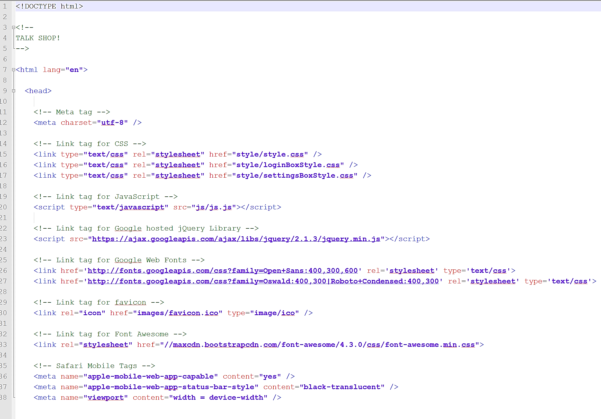

*htmlHeader.php*

A good example of this is shown in the above file. Each file in the website that uses HTML will use this file in a PHP include statement as the very first. It contains the opening HTML and opening head tag. Notice it does not include the closing head tag. This allows us to use this file across the website, but use a different title tag on various pages.

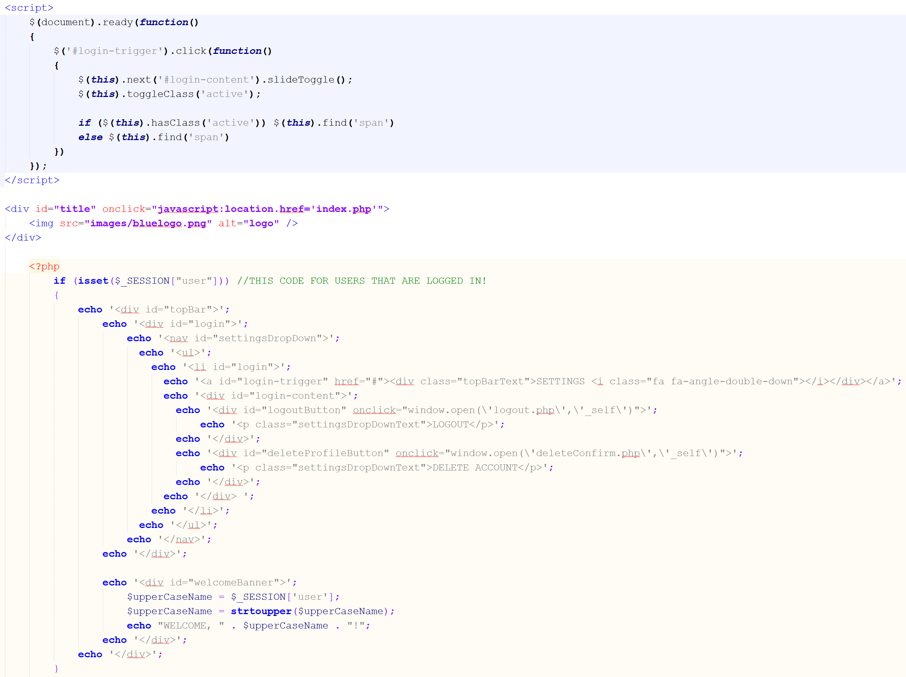

*headerBar.php*

This file contains the code for the bar at the top of each page that contains the logo. The script at the top controls the drop down box for the login form. The first part of the if statement checks to see if someone is logged in, if they are, then it will display that code which prints the logged in user’s first name and well as a drop down setting menu.

For users that are not logged in:

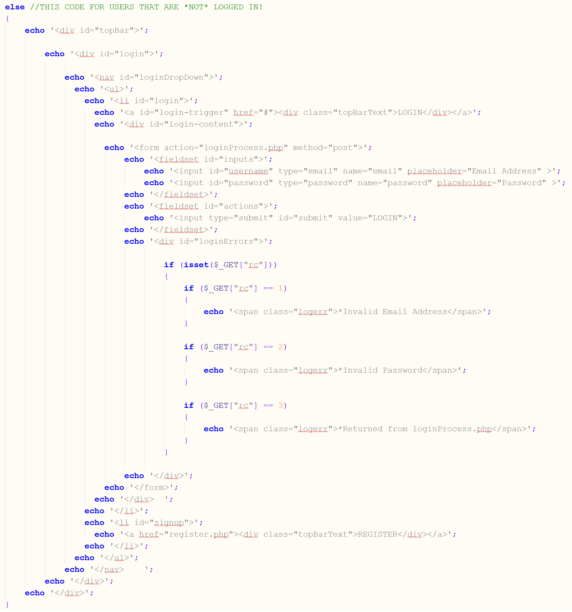

*headerBar.php*

The else statement is for users that are not logged in. It displays a login and register option.

The files teacherRegistration.php and speakerRegistration.php contain the HTML for the registration forms (too long to picture here). Everything in these files is easy to understand, as it contains mostly basic HTML for form functionality.

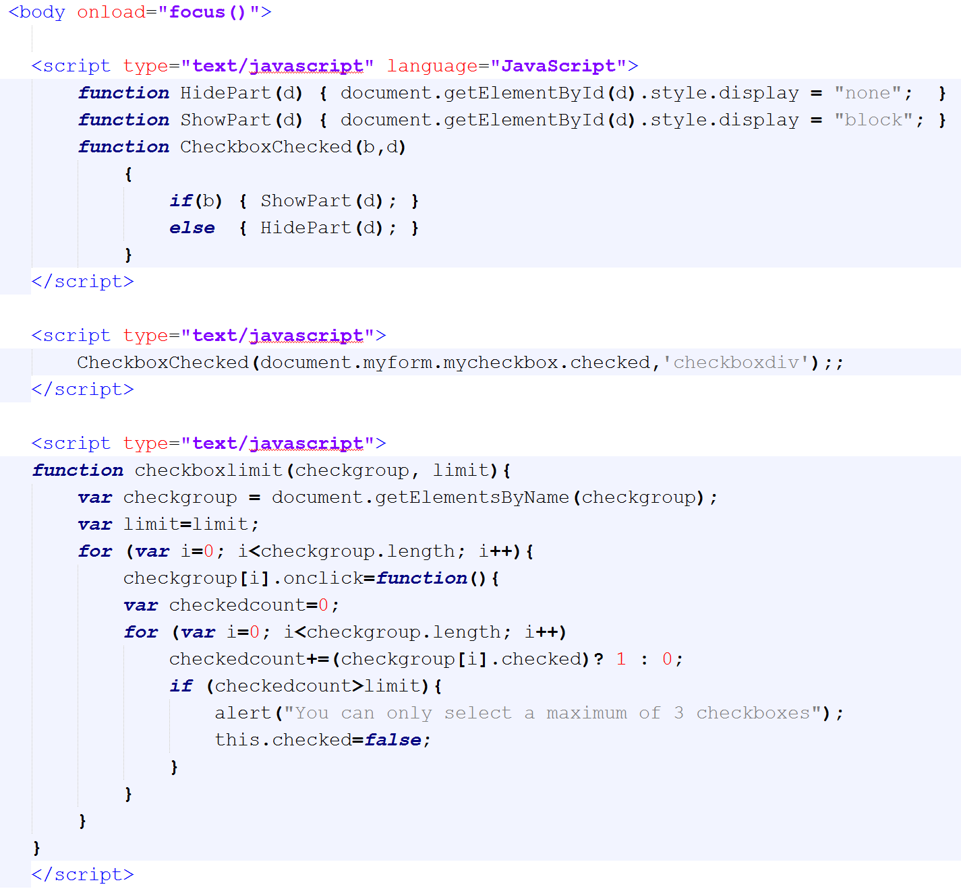*teacherRegistration.php*

JavaScript functions at the top of these files control the expansion of the form when the user checks the “Make Active Profile” checkbox. The other function ensures that the users are only selecting a maximum of three options in the topic areas section.

Once the user passes validation for either registration form, we use PHP to do a little bit more validation and upload the image. The file opens with an if statement which checks to see if the user clicked to make an active profile. If so, the code to upload the image is executed and the proper variables are set and proper SQL statement is executed.

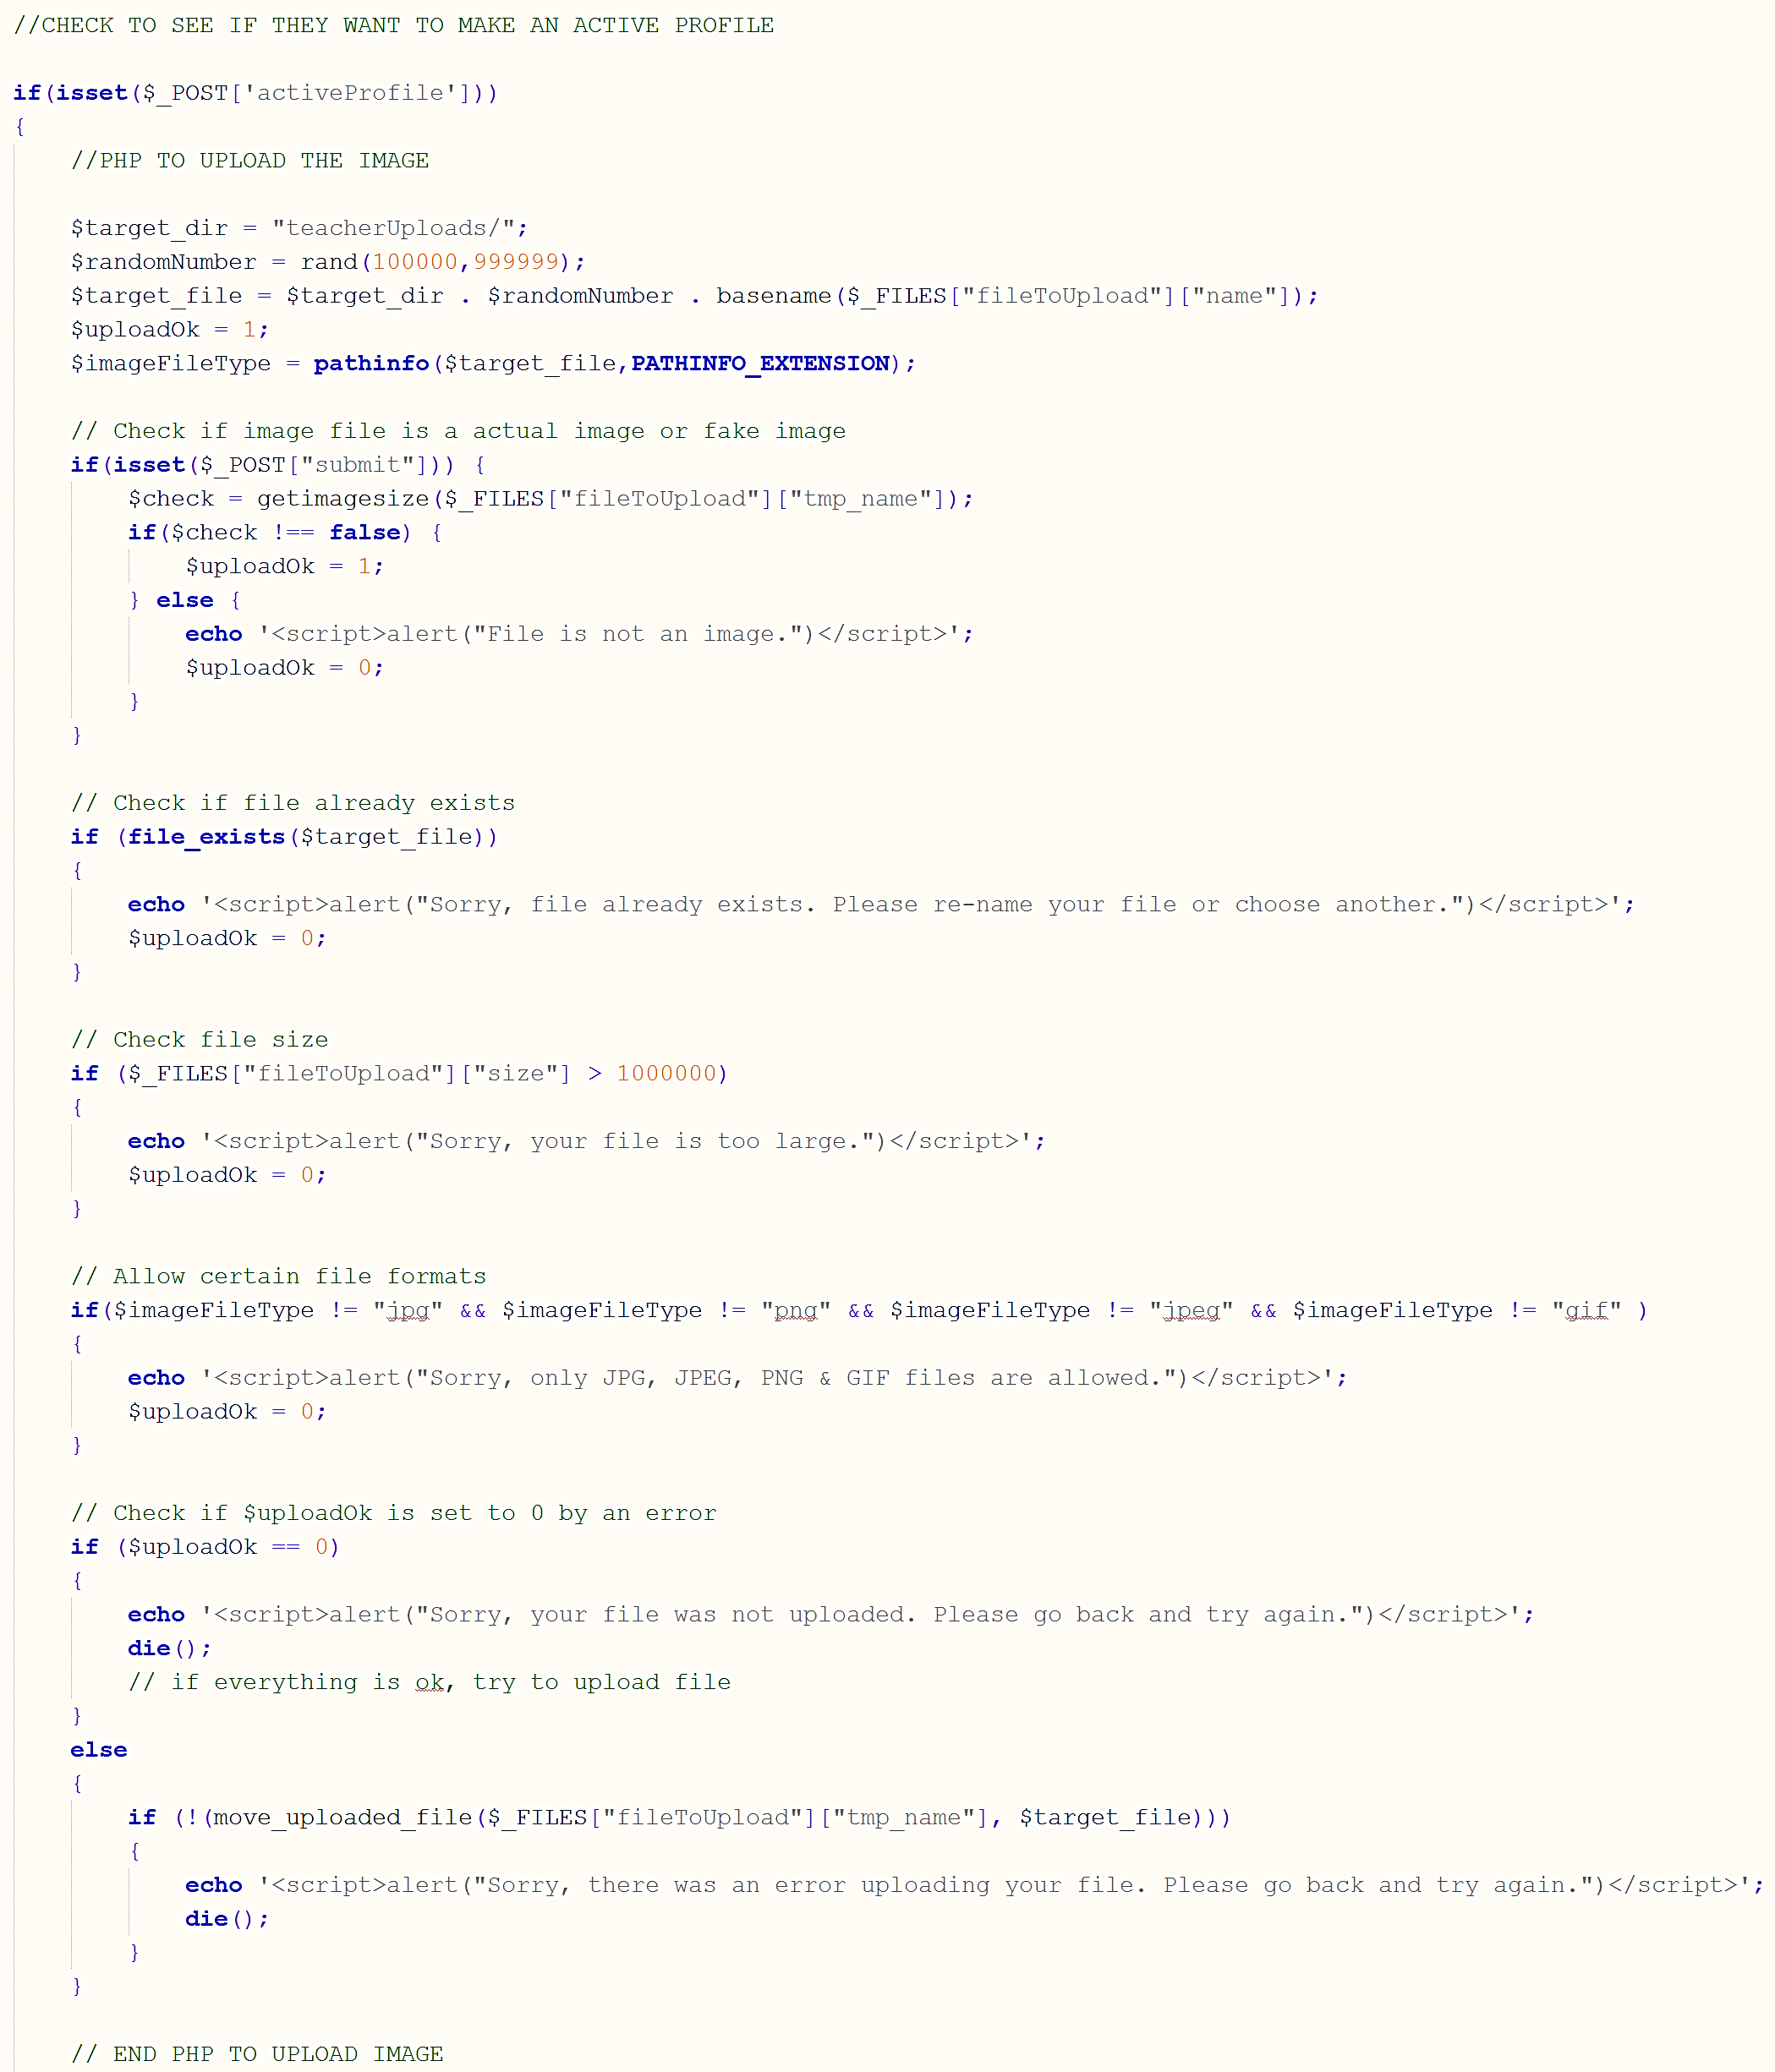

*teacherConfirm.php*

This PHP takes the uploaded image, adds a random number in front of the file name (to eliminate duplicate files names and causing problems). It also chooses the destination to store the file on the server. It will either be a folder named teacherUploads or speakerUploads, depending on which type the user is registering for. Other validity checks include the file size and file format.

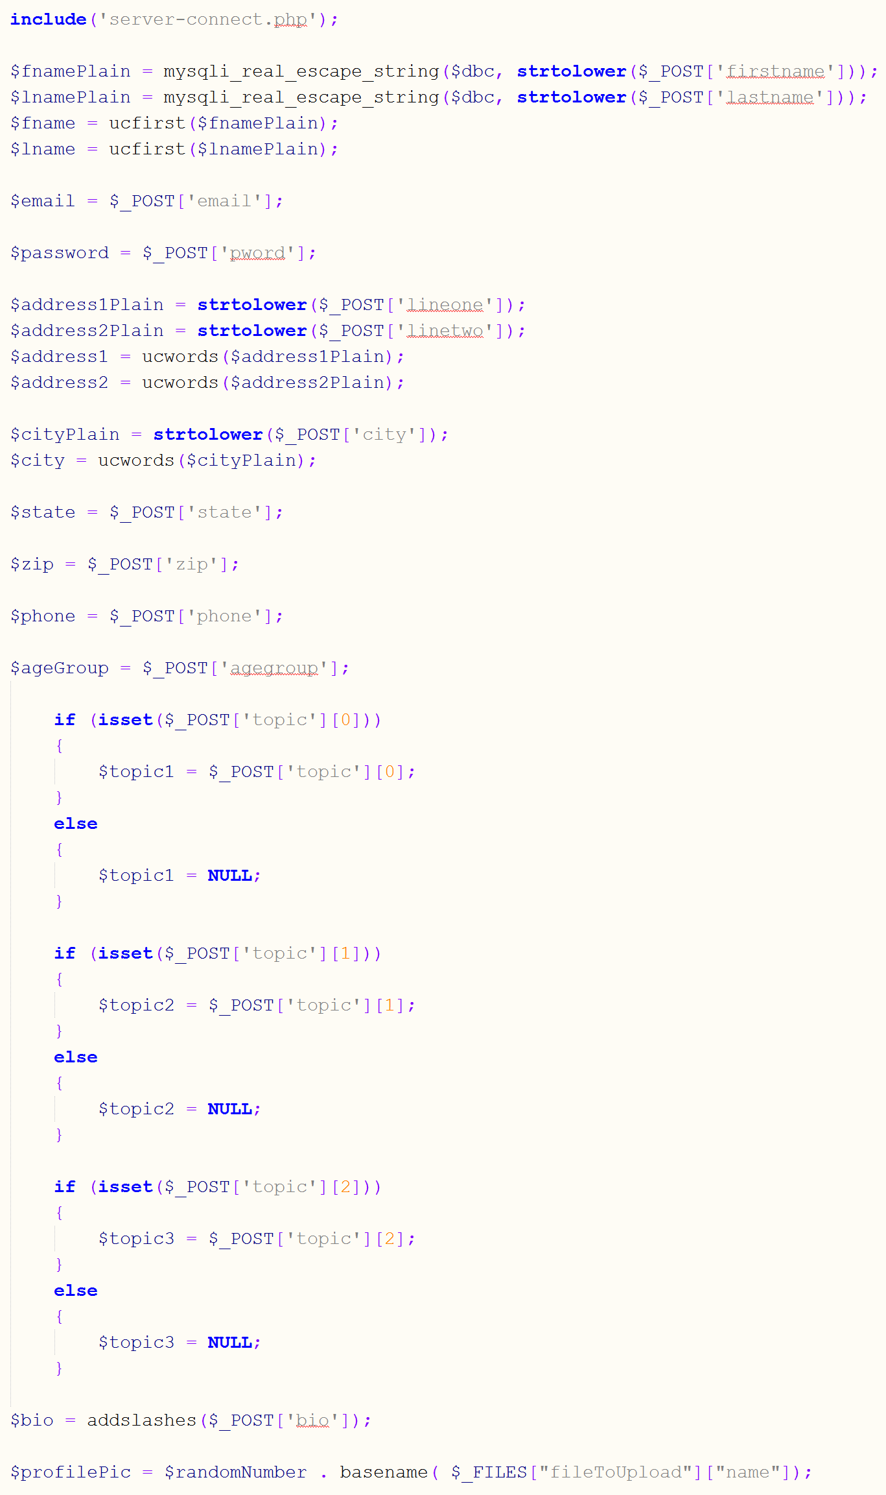

*teacherConfirm.php*

When setting the variables to insert into the database, we needed to make sure they were formatted correctly in the case that users entered all, none, or a mixture of capital letters. For the names, we escape the special characters, make everything lowercase, and then uppercase the first letter. This ensures the names will all look the same. We do the same thing with the address and city to ensure consistency. The if statements for the three topics check for values in the topic array and set the variables accordingly. The PHP addslashes() function for the bio ensures that special characters are escaped and users can input special characters in their bio without causing other issues with the database. The name of the profile picture is given the same name as the uploaded picture with the random number placed in front of the original file name. This ensures the appropriate picture is referenced in the database.

If the user doesn’t choose to create an active profile, then the else statement will be executed that does not try to upload an image and insert variables that will be null:

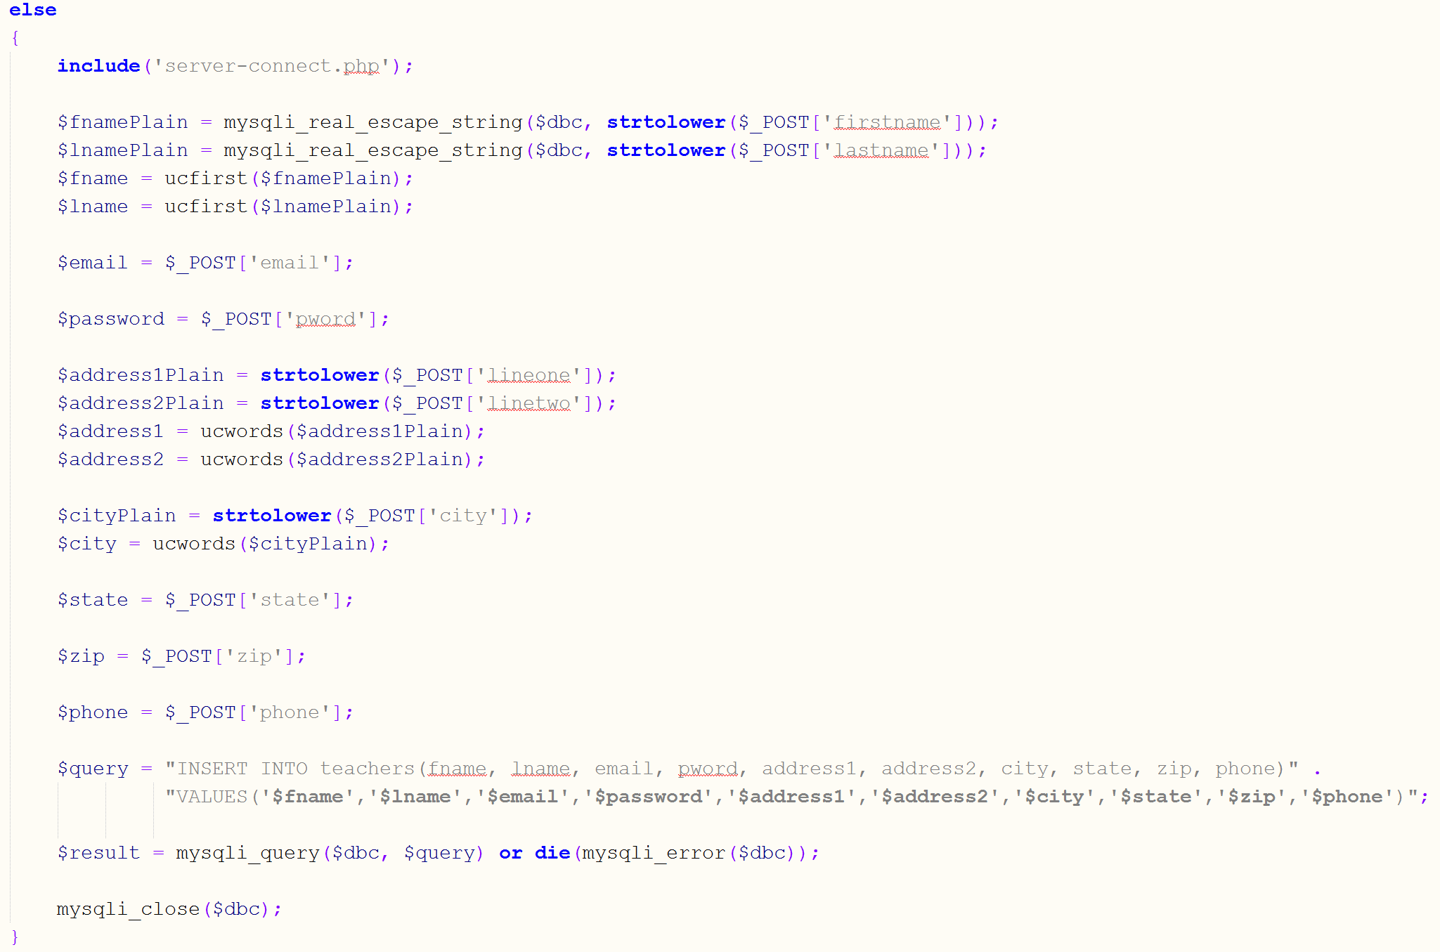

*teacherConfirm.php*

Once the picture is uploaded (if necessary) and the information is inserted into the database, the user will receive an email to let them know that have been successfully registered for TalkShop.

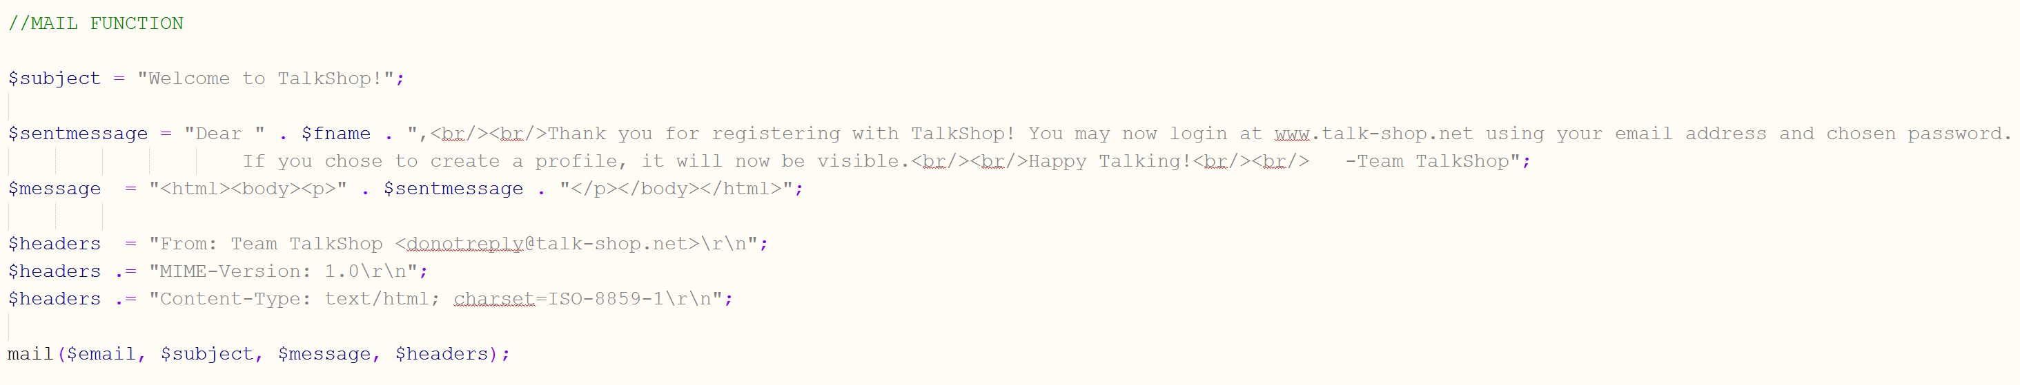

*teacherConfirm.php*

We customized an email message to use the user’s name in order to make the message more personal.

At this point, the user has successfully registered and can now login.

The code for logging in was a little tricky, since we needed to check two tables (speakers and teachers) for an email and password. As shown below, we use two of each variable by simply adding a ‘2’ for the second variable:

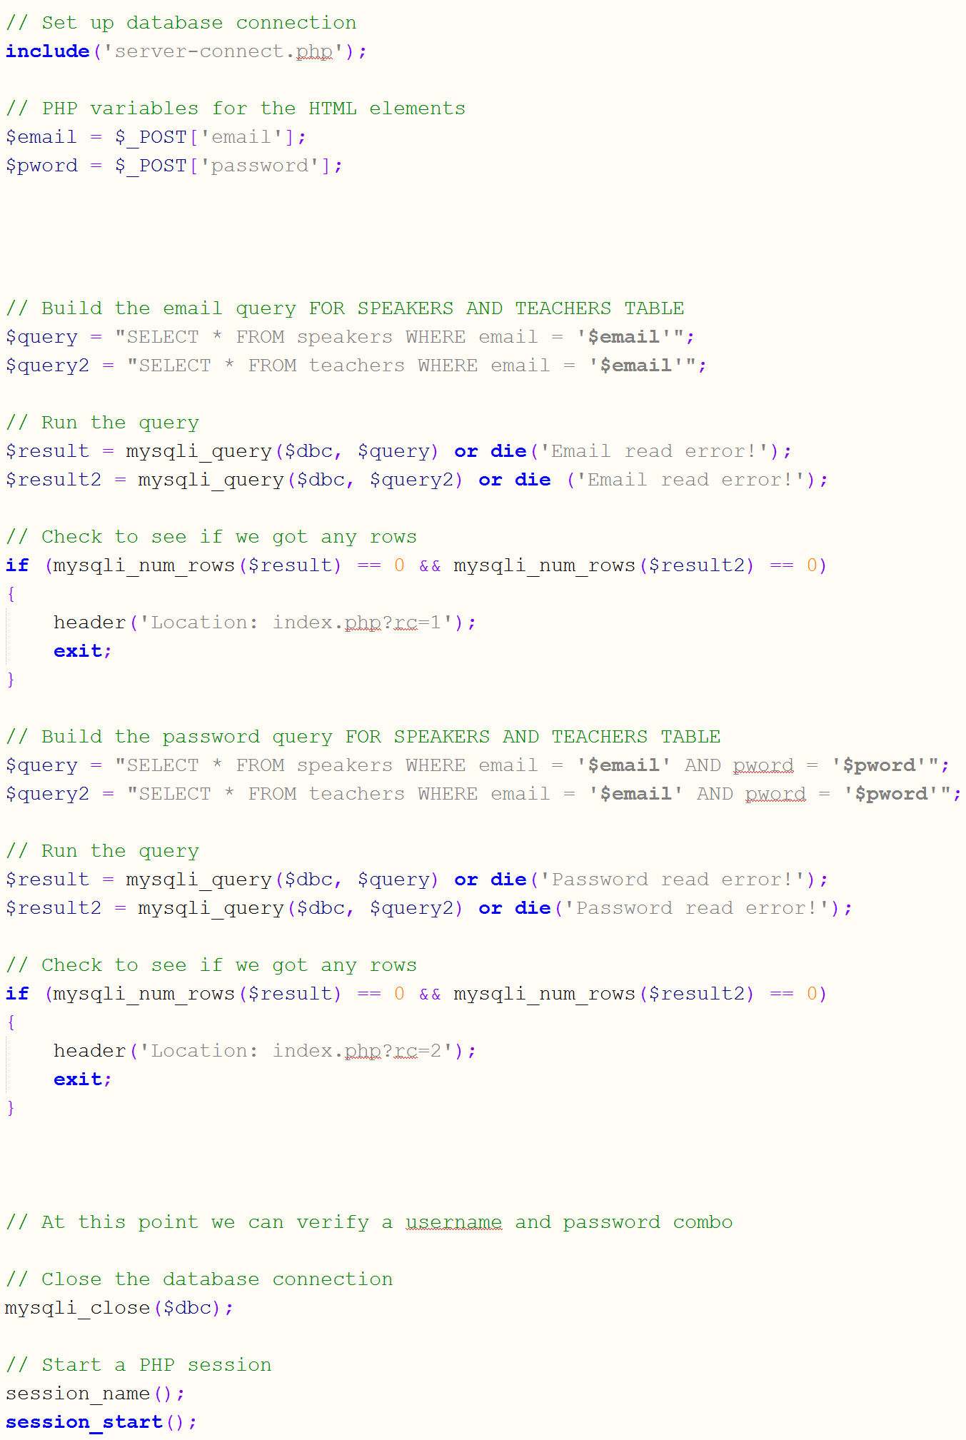*loginProcess.php*

Two queries: one for checking the teachers table and one for checking the speakers table. The if statement below checks to see which table found a matching email address and password.

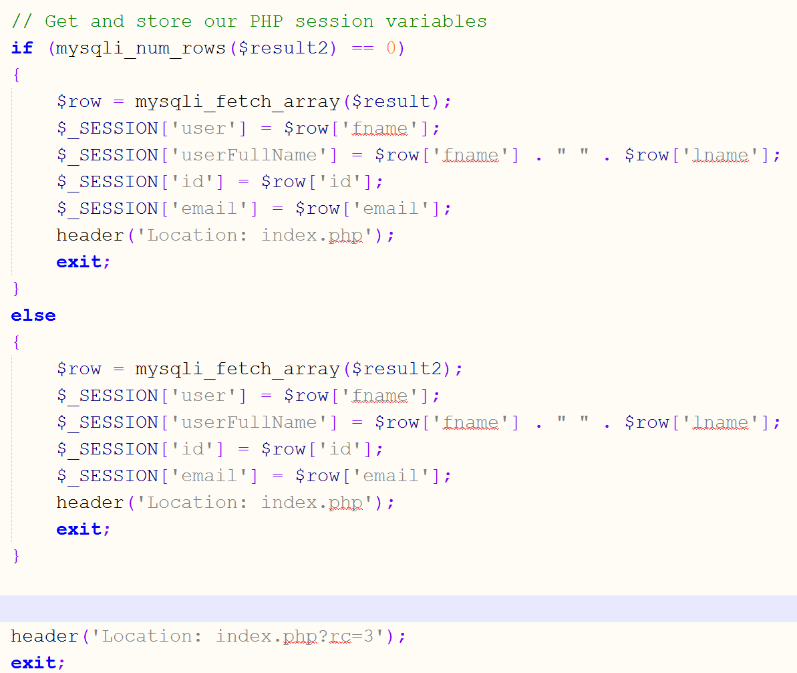

*loginProcess.php*

Once a user is logged in, the will have the option to logout or delete their account. If they choose to logout, the file logout.php will run:

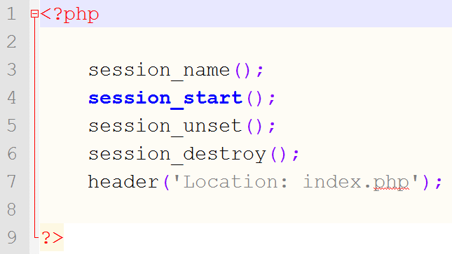

*logout.php*

The code is very simple; it simply destroys the active PHP session and loads the homepage.

If the user wants to delete the account, the code is a little more complex. We must check to see which type of account they are registered for in order to delete the information from the correct table (speakers or teachers). To do this, we run a query to see if the account exists in the speakers table. If so, then delete the matching row in the speakers table. If it doesn’t exist in the speakers table, then it must exist in the teachers table.

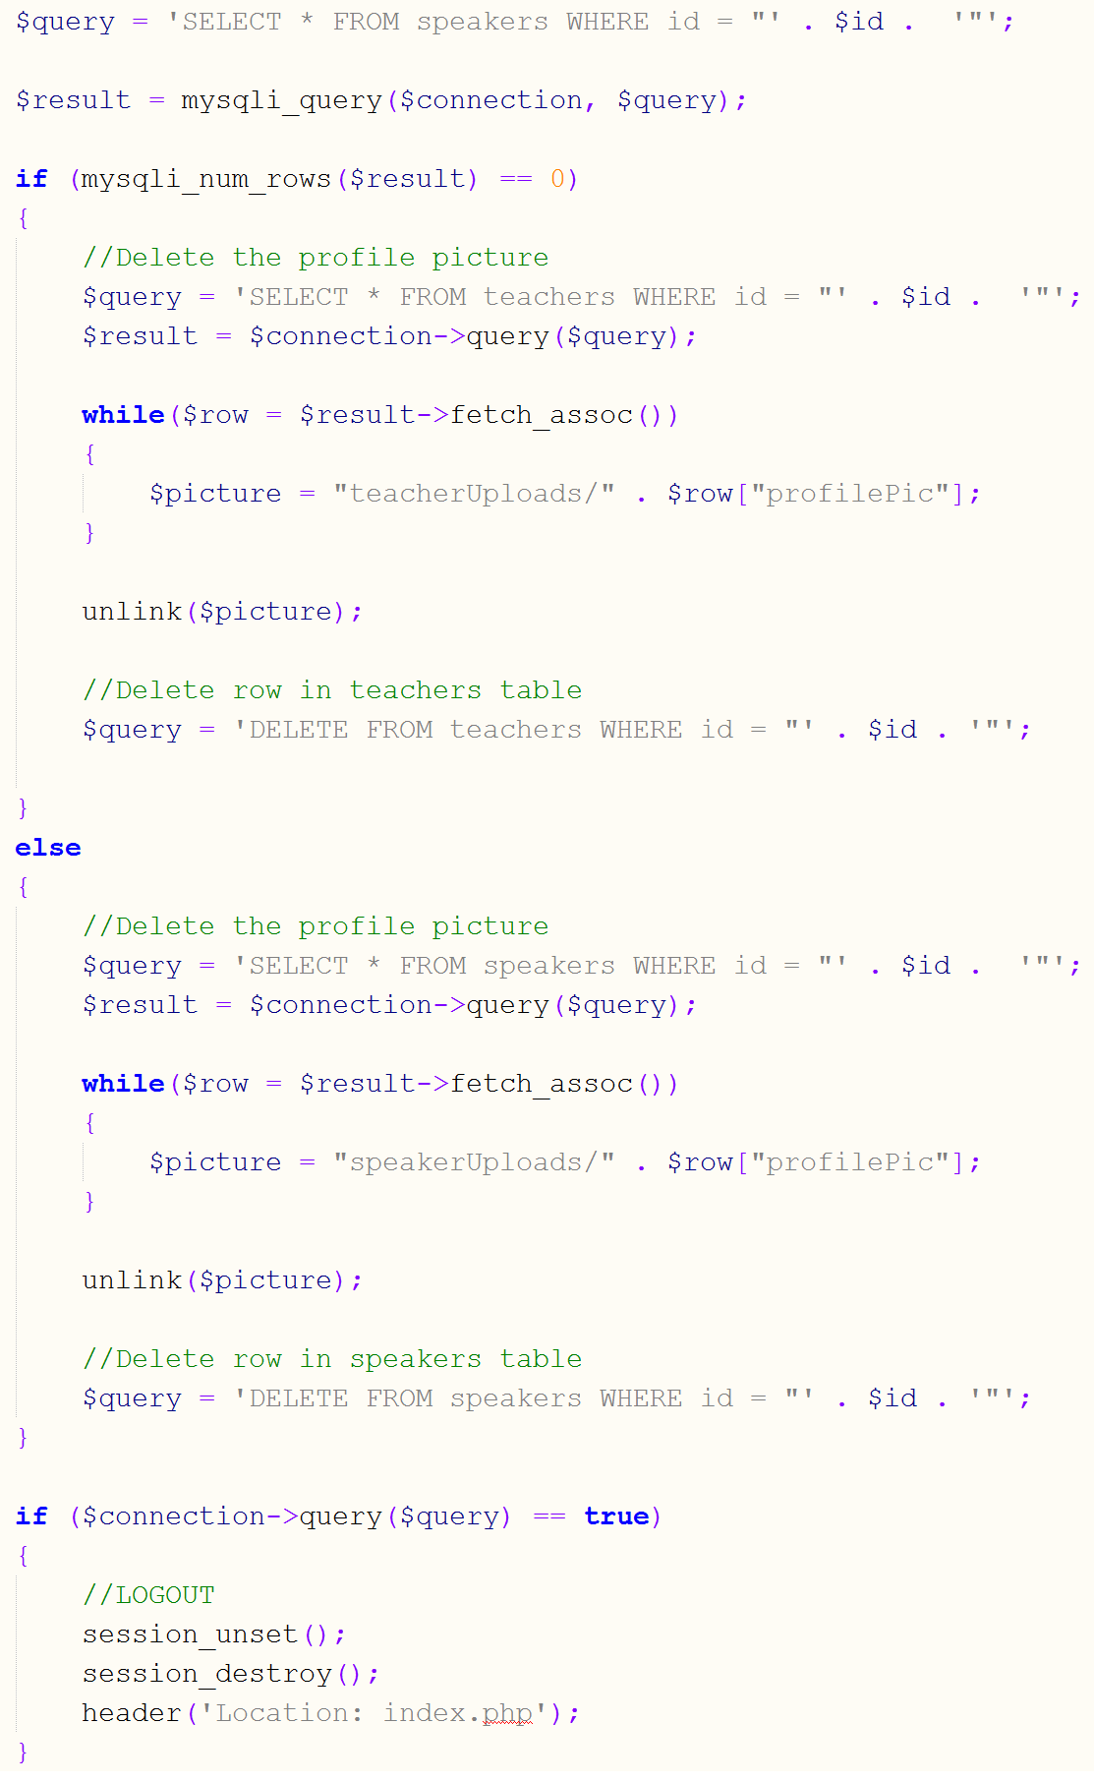

*deleteLogout.php*

After the appropriate table is decided, the code will delete the picture from the correct folder on the server and delete the row in the correct table. After this, the user is logged out by destroying the active session.

When someone wishes to view and look for listings, they are must choose to view speakers or teachers. The code of each one is about the same, but the main difference is which table the information is getting pulled from. The file that shows all listings is condensedSpeaker(Teacher)Profiles.php. It contains the search form HTML as well as the PHP to display the profiles in a list. The SQL query selects the rows where the profile picture is not null. Since users that do not choose to create an active profile will have a null value in the profile picture column, their information will not be selected to display as a profile.

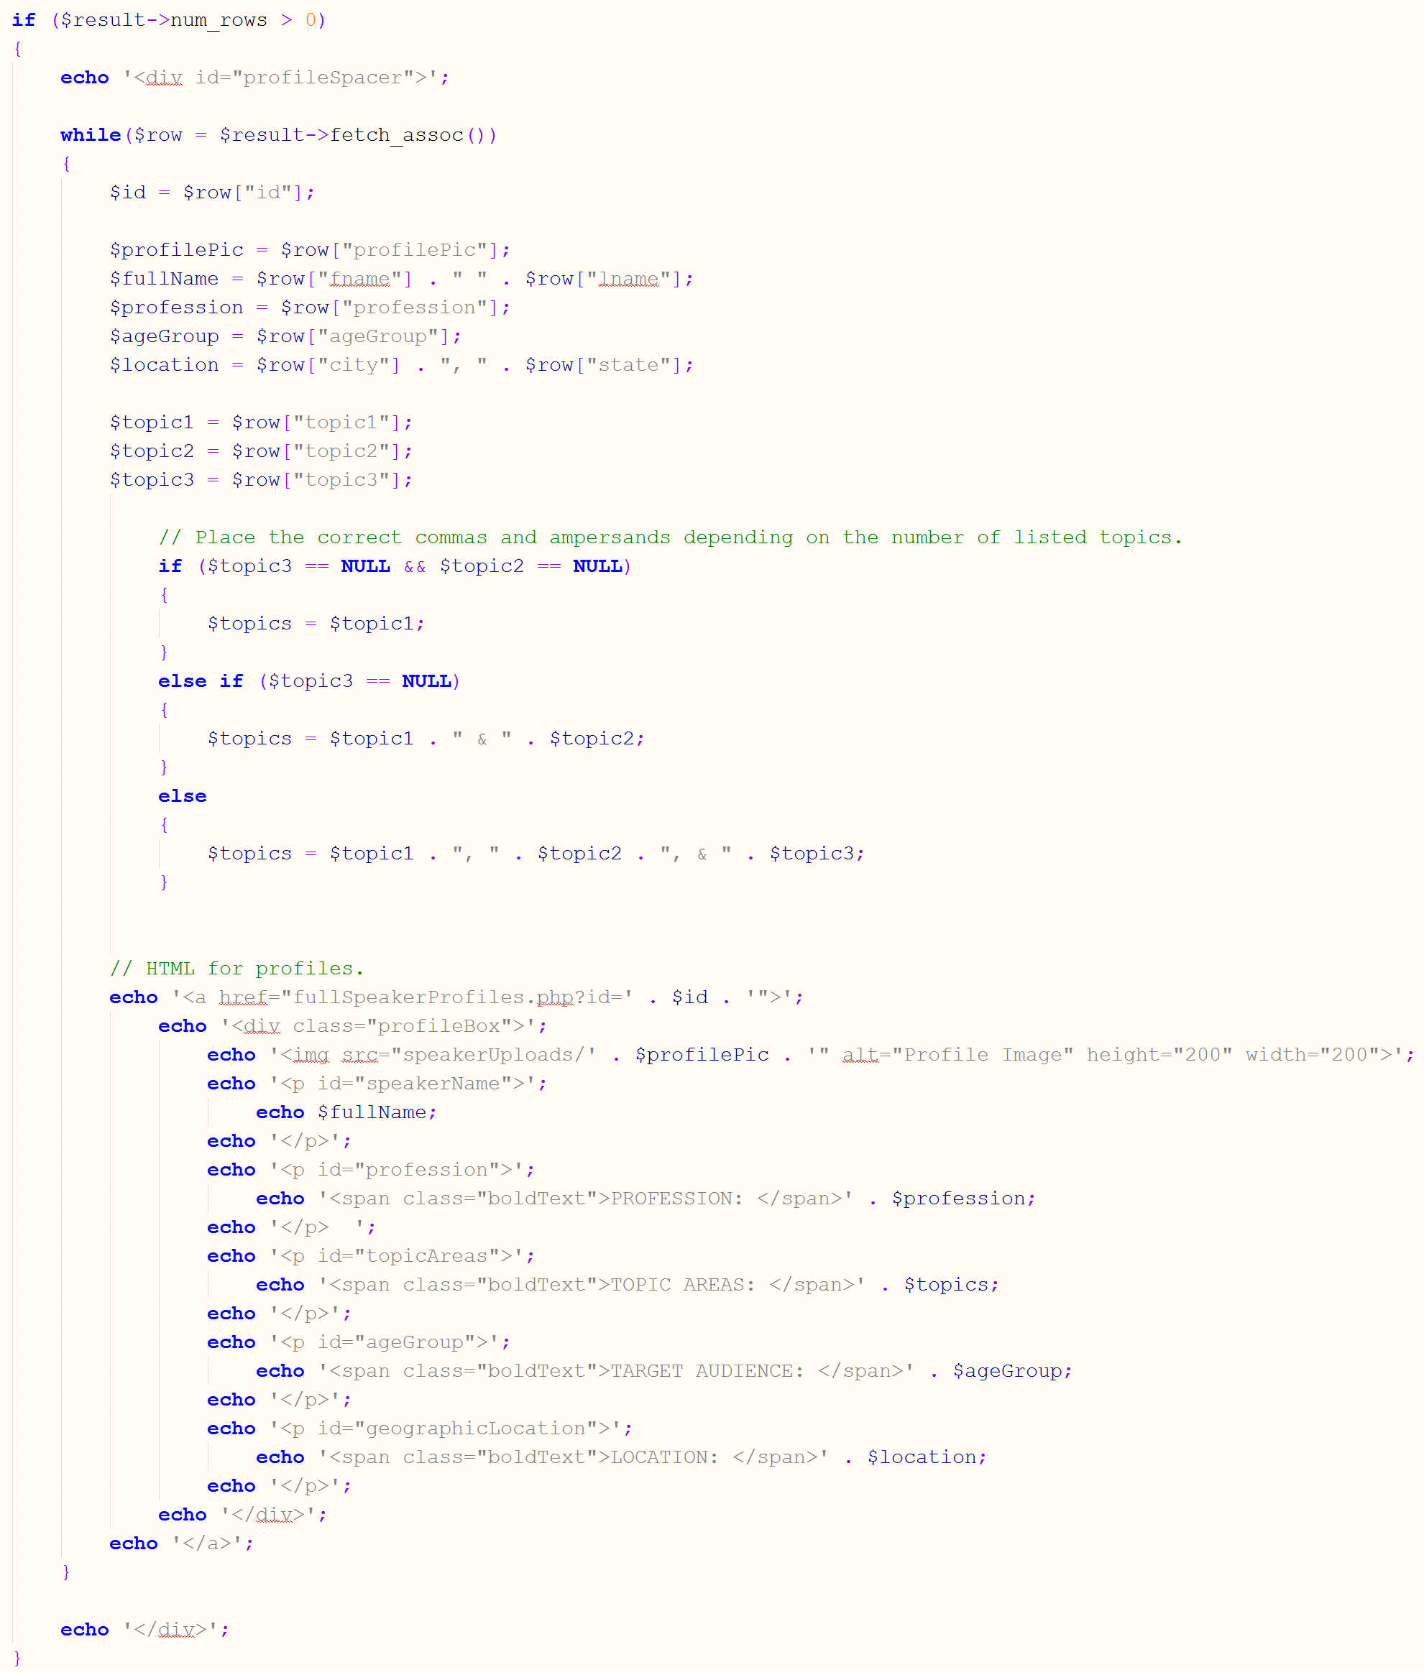

*condensedSpeakerProfiles.php*

Placing an HTML div outside of the while loop enables the profiles to appear as a list, as all of the information is being pulled from the table.

The search form on the left side of the condensed profile listings page allows users to search for a specific person. Upon clicking the Search button, the page refreshes to speaker(teacher)ProfilesSearch.php. This page is the same as condensedSpeaker(Teacher)Profiles.php, but has a different search query to only display the appropriate profiles. We use if statements to determine what fields the user is using to search to run the appropriate query.

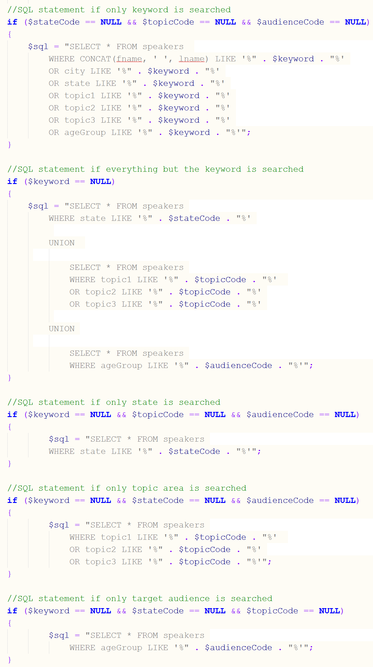

*speakerProfilesSearch.php*

When a user clicks on one of the condensed profiles, it will link them to fullSpeaker(Teacher)Profiles.php and pass the corresponding user ID to display the correct information for the full profile. We use GET to get the id from the previous page and run the query to select the row with the corresponding ID.

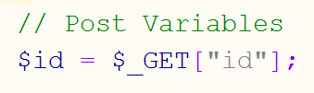



*fullSpeakerProfiles.php*

The variables are set and then used to fill in the HTML like so:

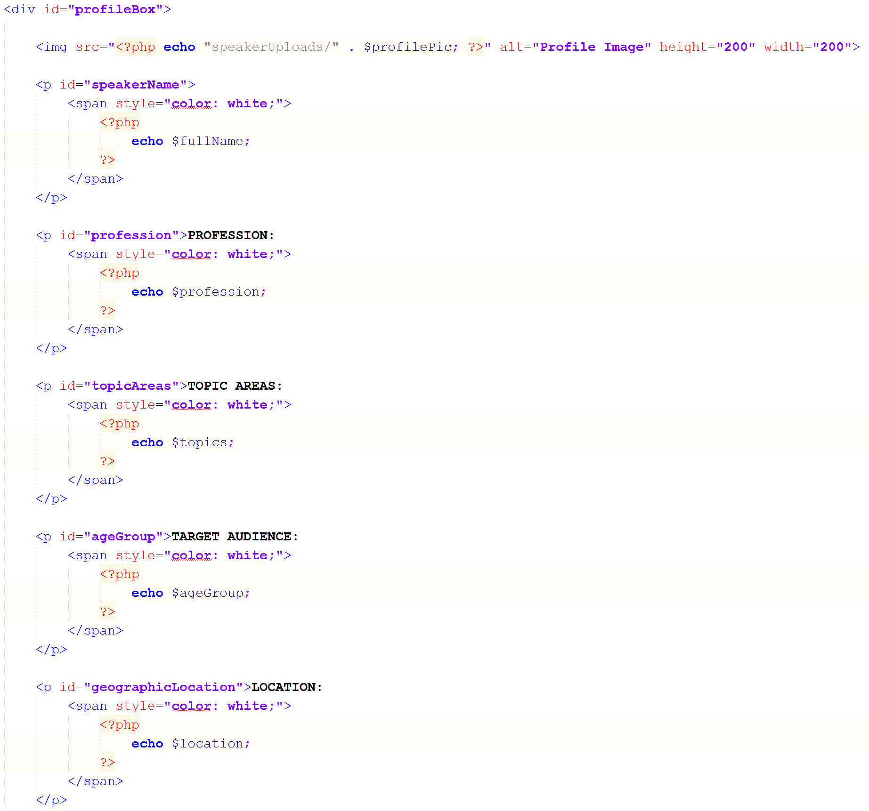

*fullSpeakerProfiles.php*

If a user wishes to contact a speaker or teacher, the must do so by clicking the contact button at the bottom of the full profiles. The user must be logged in order to send a message:

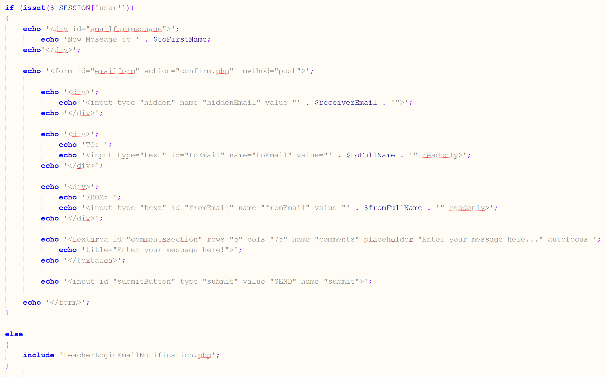

*teacherEmailForm.php*

The user ID is passed to the email page as well, as shown previously. It displays a simple form that allows a user to type a message and then send the message. Upon clicking send, the code in confirm.php executes. Confirm.php works with both speakers and teachers since the email setup is the exact same for both situations. The email function is a little more complex than the other email function because of the setting and use of many variables to make the email personal.

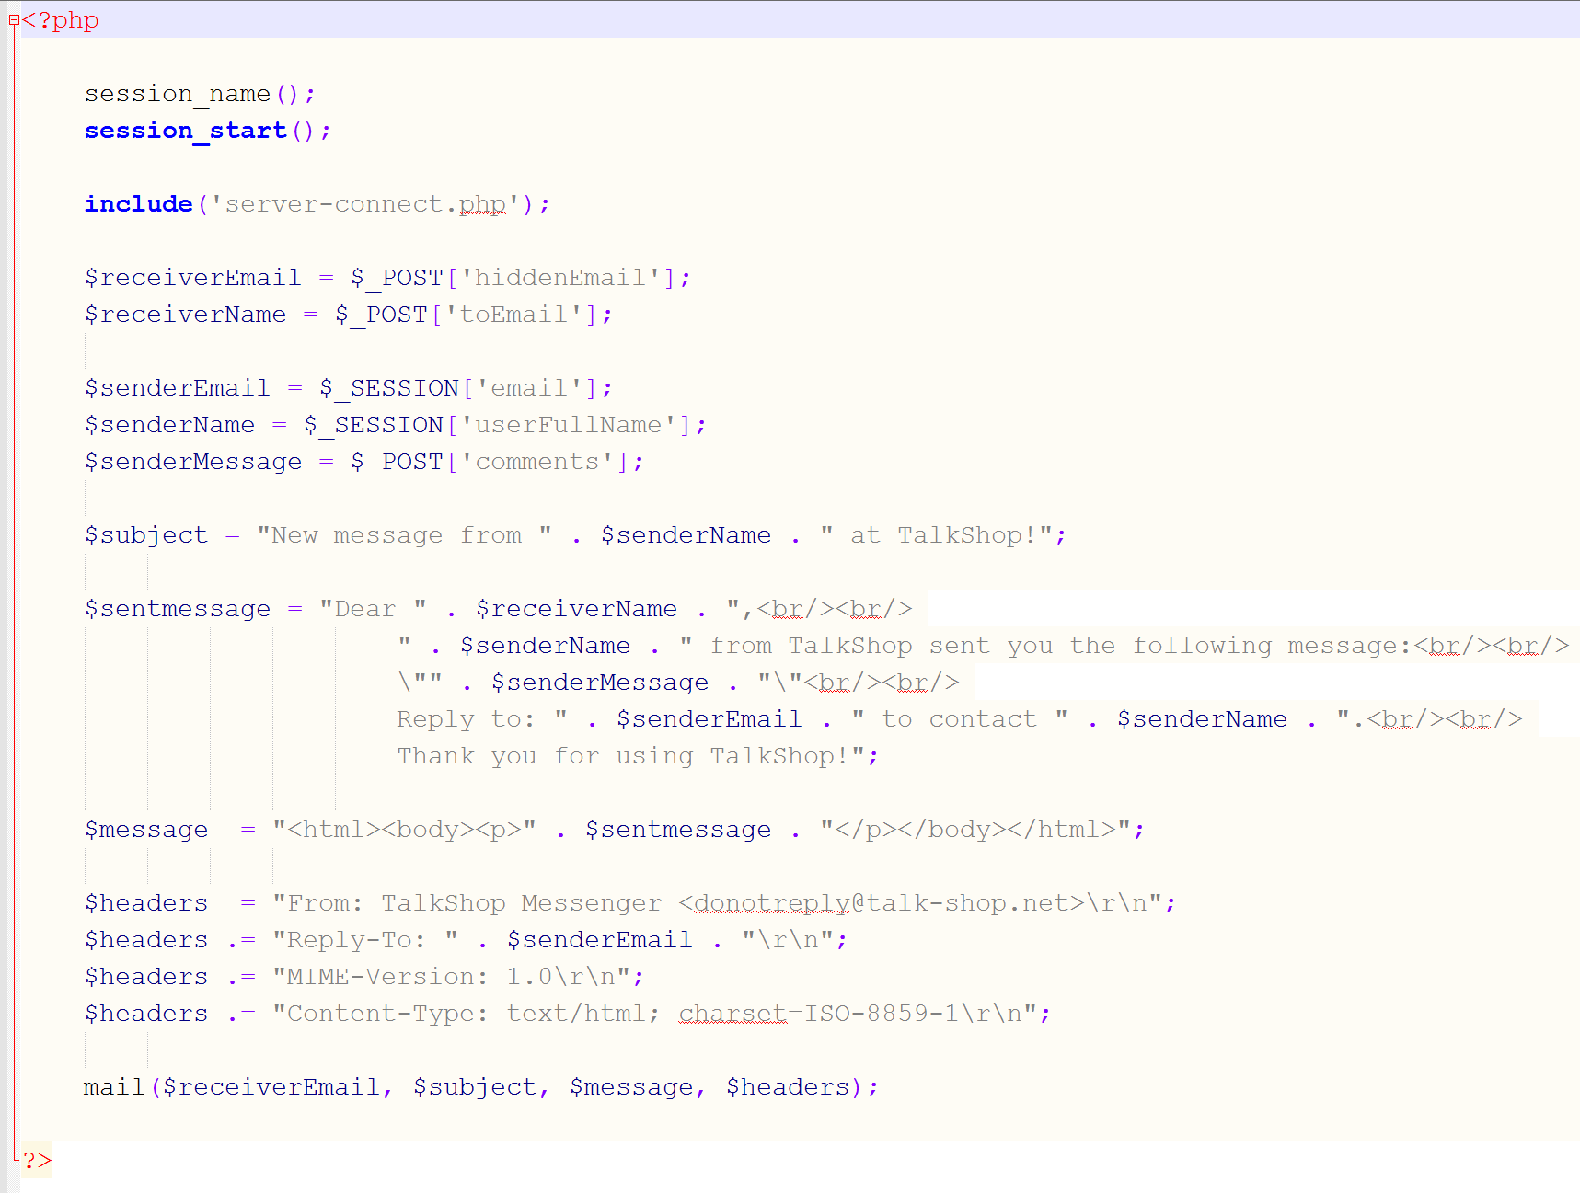

*confirm.php*

Upon the sending of the email, the user sees a confirmation page for the sent email.

Important GoDaddy Information

GoDaddy Account:

**USERNAME:** talkshopgroup

**PASSWORD:** Asu275833

**CUSTOMER #:** 98555524

**PIN:** 3751

**EMAIL:** [jkhumpherys@gmail.com](mailto:jkhumpherys@gmail.com)

Linux cPanel:

**USERNAME:** talkshopadmin

**PASSWORD:** Asu275833

Email Accounts:

**ACCOUNT:** info@talk-shop.net

**PASSWORD:** Asu275833

**INCOMING SERVER:** p3plcpnl0180.prod.phx3.secureserver.net

**OUTGOING SERVER:** p3plcpnl0180.prod.phx3.secureserver.net

**ACCOUNT:** DoNotReply@talk-shop.net

**PASSWORD:** Asu275833

Connect to Database (GoDaddy):

**$servername** = 'localhost';

**$username** = 'talkshopconnect';

**$password** = 'Asu275833';

**$db** = 'talkshop';

Testing and Evaluation

Testing

For our 0.3 release we were required to get user feedback with our basic navigation designed. As a team we decided to use our resources at Arizona State and get opinions from our professors. Looking back on this, this was not the best decision for receiving feedback as most of the professors had more advice on concept and pivoting to an entirely new idea. We should have targeted the premier audience of our website by getting opinions of middle and high school teachers. We undoubtedly would have had more valuable feedback to enhance our vision for TalkShop. Another flaw that hindered our ability to get beneficial feedback was that our professors had difficulty envisioning the flow of the website. The team probably needed at least two more releases to have an improved navigation design. This would have allowed our users to fully experience the design and provide us the targeted feedback we were looking for. Overall the feedback we did receive included that the website had a very professional and clean look. Some professors recommended a home button for the older users who may not be aware that the TalkShop logo would return them to the homepage. Finally some were confused with connect with speakers/teachers button and recommended switching to “I’m a Speaker/Teacher”. As a team we considered all the opinions of the feedback that we received and decided to not implement their recommendations.

Automation

Our final part of testing was to ensure that we had scripts that would test the website. As a team, we decided that it would be best to design a smoke suite to test all the basic functionality such as logging in, making and deleting an account, and basic search functions. Since, our product owners will continue to add features that they want to implement they can use this suite to ensure that new code introduced did not break any of the functionality that has been created allowing them to save countless hours of validating.

Moving Forward

As of now, talk-shop.net is live and fully functional. Users are able to register, login, create a profile, and connect with teachers or speakers with ease. The team does not intend on making any further changes beyond this point; however, we will continue to encourage people to visit the site and recruit new members. As for future TalkShop development teams, we have comprised a list of suggestions for enhancing the website:

* **New Domain:** The clients wish to transfer the site to <http://www.talkshopspot.com>. A temporary fix would be to redirect; however, the task should be fairly simple. This should be addressed immediately.
* **Listings:** Currently, when users choose to create a profile, they fill out information about themselves and the bio is then posted to the speaker or teacher profile pages. Instead of users searching through profiles, implement a functionality that allows users to only post a listing for what they need at that point in time. Similar to creating an ad on Craigslist, consider developing a “Create a Listing” button that will include the date and time a speaker is needed and the particular topic the teacher is looking for.
* **Edit Account Info:** At this point, there is no way for a user to edit their account information. If they want to update their profile, they must delete their current one and start over. This is very inconvenient and should be considered a top-priority moving forward.
* **Premium Listings:** As the site gains more users, it may be beneficial to offer premium listings at a reasonable price. Speakers could have the option to pay for a more visible space on the website so that they can acquire more business.
* **Rating System:** Developers should consider implementing a rating system in which teachers could rate speakers on their performance. Perhaps you could correlate the rating with the position of the speaker on the page, meaning the higher the rating, the more visible the speaker is on the site. Developers could also add rating into the search criteria.